# Lab 1 - HTML5, CSS3, JS

# Tweet Ticker

Tweets are provided in JSON format in the file tweets.json.

‘tweets.json’ is an array of tweet objects of the form [{tweet1},{tweet2},{tweet3},.. ,{tweet150}].

Open tweets.json in a code editor to understand the format of tweets

Read: <http://json.org/>

Read: <https://dev.twitter.com/docs/entities>

Create a Tweet Ticker, which will show tweets from the JSON file, 5 tweets at a time and will slowly cycle through the tweets every three seconds.

Use CSS3 transitions and animations (or jQuery animations) to make the tweets cycle through the ticker smoothly.

Example:

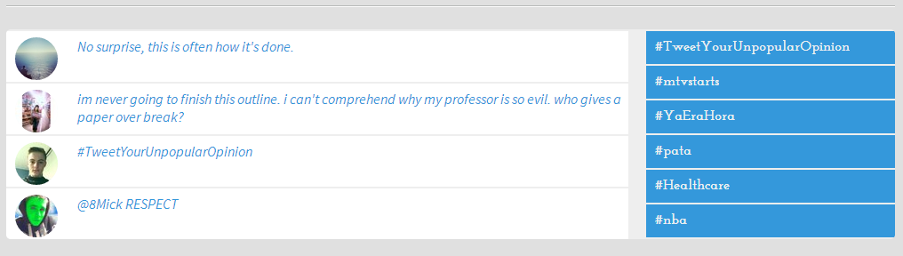

You will be graded on the following;

Formatting and coding style : 10

Objective 1 – Processing JSON : 10

Objective 2 – Displaying output : 10

Creativity/Coding style : 10

Documentation/Read.me : 10